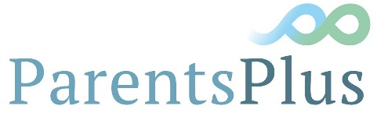
Contract of Agreement for Parents Plus Healthy Families Programme Sponsorship
Participation in the Parents Plus Heathy Programme pilot study allows successful applicants to receive all the items below free of charge from the Parents Plus Charity
- Full Healthy programme materials (manual, video, parent book)
- Training in the Healthy Families Programme over five modules
- Parent books for your first group
- Post training supervision.
- Support towards becoming an accredited facilitator.

Conditions of Participation in the Pilot : Each facilitator must agree to:
- Attend the introduction seminar with your line manager on Friday 17th June 10am-11:30am
- Attend the facilitator training online by zoom 1st, 2nd, 8th and 9th September 2022 9:30am-1pm
- Recruit 8-15 parents for a healthy families group to start in Autumn 2022 or early 2023
- Co-facilitate an eight week group delivered online or face to face
- Meet all parents for and individual meeting to collect research data and to set goals for the group
- Note the time commitment to deliver the group can be one day a week for the duration of the programme (1.5 - 2.5 hour group, one hour meeting with co-facilitator, one hour preparation and one hour follow up with parents/young people).
- Participate fully in the supervision offered by Parents Plus ( 2 group sessions and 2 individual sessions)
- Follow the Parents Plus Manual and evidence-based Quality Protocol in the delivery of the groups and collect post-group research data from parents.
- Comply with Parents Plus Licensing Guidelines here.
*All relevant people to sign below to confirm that they have read and agree to the conditions above
Name of First Facilitator | Organisation/Location | Signature | Date
Name of Second Facilitator | Organisation/Location | Signature | Date
Name of First Line Manager | Organisation/Location | Signature | Date
Name of Second Line Manager | Organisation/Location | Signature | Date

